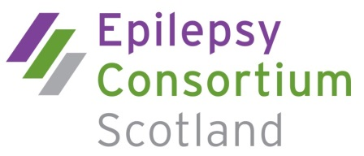

Membership application form
Our membership includes organisations, professionals and individuals who seek to improve health, social care and public policy relating to epilepsy.
Membership categories are as follows:
Organisational member
Membership fee is based on income and the organisation has one vote
Associate member
Nominated by an organisation where the person has a special interest or expertise in epilepsy – no voting rights
Professional member
There is a fixed membership fee and the professional member has one vote
Individual member (Maximum of 5)
A person with epilepsy and/or parents and carers of people with epilepsy – one vote for each individual member

Please complete the following details:
Name
Job title
Organisation (if applicable)
Organisation address
Town Post code
Telephone number: Mobile
email:

For associate membership only please complete the following:
Nominating member organisation
Proposed by:
Name of nominee
Job title
Address
Town Post code
Telephone number: mobile:
email:

kk

lllllllllllllllllllllllllllllllllllll

jjjjjj

lllllllllllllllllllllllllllllllllllll

jjjjjj

lllllllllllllllllllllllllllllllllllll

Membership Fees
Membership runs in line with the financial year April – March. Fees will be reviewed annually.
Income Band | Full fee
Organisational member
Income > £250,000 | £250
Income > £50,000 | £125
Income < £50,000 | £55
Associate member | Membership through organisation
Professional member | £25
Individual member (max 5) | No fee

Please tick which membership category you wish to apply for:

I wish to apply for Organisational membership to ECS

kk

lllllllllllllllllllllllllllllllllllll
I wish to apply for Associate membership to ECS*

kk

lllllllllllllllllllllllllllllllllllll
I wish to apply for Professional membership to ECS

kk

lllllllllllllllllllllllllllllllllllll
I wish to apply for Individual membership to ECS
*If applying for Associate membership, please state the contribution the individual will make towards the ECS aims and Objectives

As a member of ECS you will receive member mailings, email briefing and updates on our current campaigns and events. Your details will not be given to a third party
If this membership application is approved, I/we agree to abide by the ECS guidelines

Signature Date

Print name

Please return your completed application to:
The Chair, Epilepsy Consortium Scotland, c/o Epilepsy Scotland, 48 Govan Road, Glasgow G51 1JL

