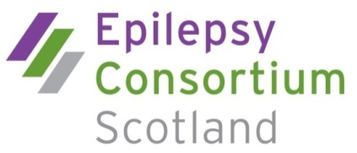

Become a member of the Epilepsy Consortium Scotland (ECS)
- Be the voice and vision for change for people with epilepsy
What is ECS?
ECS brings together organisations and individuals to inform those shaping public policy and practice about issues facing around 55,000 people with epilepsy in Scotland. ECS acts as the collective voice for the wider Scottish epilepsy community.
Who can apply to join?
Those who want to engage with our work for people with epilepsy:
- Allied health and social care professionals
- Public education providers
- Third sector organisations
- Researchers and academics
- Decision makers interested in epilepsy-related issues
- Corporate agencies involved in epilepsy service provision
- Individuals with epilepsy or those with associated expertise
What we offer
The benefits of being part of ECS include:
- Pooling knowledge and expertise across different sectors
- Helping to influence future policy/guidelines and practice at Government level
- Contributing to national consultations affecting people with epilepsy/carers
- Informing the work of the Scottish Parliament Cross-Party Group on Epilepsy
- Updates on relevant Scottish-based issues in the epilepsy community
- Commenting on the integrated health and social care agenda
- Networking and events
- Working together for the common good of people with epilepsy
Membership fees
- Organisational member: £55, £125 or £250 a year based on annual income
- Professional member: £25
- Associate Organisational member: £40 (conditions apply)
- Associate member: Membership through nominating organisation
- Individual member (max of 5): No fee
For more information or an application form, please get in touch on 0141 248 4125 or email enquiries@epilepsyconsortiumscotland.co.uk or visit online: www.epilepsyconsortiumscotland.co.uk

