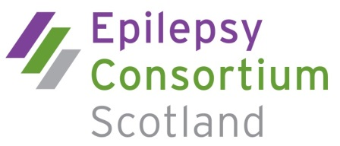

Membership application form
Our membership includes organisations, professionals and individuals who seek to improve health, social care and public policy relating to epilepsy.
Membership categories are as follows:
Organisational member
Membership fee is based on income and the organisation has one vote
Associate member
Nominated by an organisation where the person has a special interest or expertise in epilepsy – no voting rights
Professional member
There is a fixed membership fee and the professional member has one vote
Associate Organisational Member (attends meetings however has no voting rights, will receive meeting minutes, can participate in research and data collection.
Individual member (Maximum of 5)
A person with epilepsy and/or parents and carers of people with epilepsy – one vote for each individual member

Please complete the following details:
Name
Job title
Organisation (if applicable)
Organisation address
Town Post code
Telephone number: Mobile
email:

For associate membership only please complete the following:
Nominating member organisation
Proposed by:
Name of nominee
Job title
Address
Town Post code
Telephone number: mobile:
email:

kk

lllllllllllllllllllllllllllllllllllll

jjjjjj

lllllllllllllllllllllllllllllllllllll

jjjjjj

lllllllllllllllllllllllllllllllllllll

Membership Fees
Membership runs in line with the financial year April – March. Fees will be reviewed annually.
Income Band | Full fee
Organisational member
Income > £250,000 | £250
Income > £50,000 | £125
Income < £50,000 | £55
Associate member | Membership through organisation
Professional member | £25
Associate Organisational member | £40
Individual member (max 5) | No fee

Please tick which membership category you wish to apply for:

I wish to apply for Organisational membership to ECS

kk

lllllllllllllllllllllllllllllllllllll
I wish to apply for Associate membership to ECS*

kk

lllllllllllllllllllllllllllllllllllll
I wish to apply for Professional membership to ECS

I wish to apply for Organisational Associate membership to ECS

kk

lllllllllllllllllllllllllllllllllllll
I wish to apply for Individual membership to ECS
*If applying for Associate membership, please state the contribution the individual will make towards the ECS aims and Objectives

As a member of ECS you will receive member mailings, email briefing and updates on our current campaigns and events. Your details will not be given to a third party
If this membership application is approved, I/we agree to abide by the ECS guidelines

Signature Date
Print name

Please return your completed application to:The Chair, Epilepsy Consortium Scotland, c/o Epilepsy Connections, 100 Wellington Street, Glasgow, G2 6DH

